Unit Title: Tiriti o Waitangi |  |  | Year: 9
Achievement Objective(s):
AO3: Understand how cultural interaction impacts on cultures and societies.
AO2: Understand how the Treaty of Waitangi is responded to differently by people in different times and places.
Key Competencies: |  | 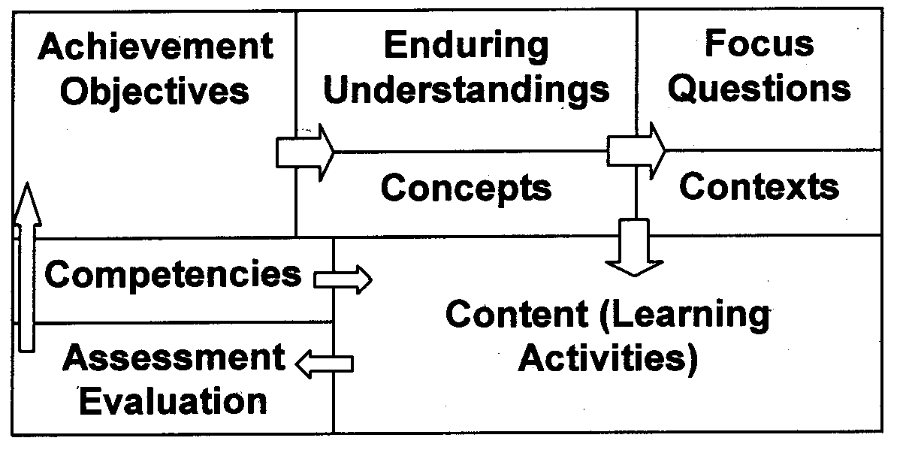
Concepts:  Identity, Culture, Society,  Treaty of Waitangi, Kawanatanga, Rangatiratanga, Sovereignty, Governorship | Enduring Understandings:  - Cultural groups had differing perspectives/world views.  - There have been a variety of on-going responses to the Treaty of Waitangi.  - The Treaty did not deliver on the expectations of many who were involved in the process.
Contexts:  - Aotearoa/New Zealand, Pre-European NZ, Te Iwi | Focus Questions:  - What were the perspectives of the various groups involved?  - How did groups and individuals respond to the Treaty?
Content (Learning Activities using the Paki Chronicles Books 1-5)

Context: Cultural Interaction
Focus Question 1: What were the perspectives of the various groups involved in the production/signing of the Treaty of Waitangi? (Causes)
- Views on land ownership - Venn diagram
- Perspectives task sheet using Books 1 & 2.

Context: Treaty of Waitangi and responses
Focus Question 2: How did groups and individuals respond to the Treaty? (Consequences)
- Treaty of Waitangi Treasure Hunt using Books 3 & 4
- Continuum exercise – “ Signing of the Treaty”. Add viewpoints of missionaries, various Maori chiefs, Hobson and Busby. Annotate with reasons for viewpoints.
- Timeline of the consequences using Book 5

Extension idea:
Use the movie “Waitangi – What Really Happened” in conjunction with the books. Choose a couple of key pages, blank out the words in the speech bubbles and get students to add words whilst watching the movie.

Assessment / Evaluation:

- Paragraph writing assessing ability to structure and write with precision. Compare and contrast the perspectives of the various stakeholders involved in the signing of the Treaty of Waitangi.

